

Assessment Cover Page
Student Full Name Allaa boudouara
Student Number
Module Title.
Machine Learning
Assessment Title: CA1
Lecturer/Supervisor Mohammed Iqbal
Assessment Due Date | 19/05/2026
Date of Submission
Use of AI Tools
Choose the statement that fits your work and delete the other.
Declaration
By submitting this assessment, I confirm that I have read the CCT policy on academic misconduct and understand the implications of submitting work that is not my own or does not appropriately reference material taken from a third party or other source.
I declare it to be my own work and that all material from third parties has been appropriately referenced.
I further confirm that this work has not previously been submitted for assessment by myself or someone else in CCT College Dublin or any other higher education institution.
I acknowledge the use of [enter name of the AI tool you used] for the purpose of [provide a brief explanation of how you used the tool].
I have not used any AI tools or technologies in the preparation of this assessment
Github assignment link https://github.com/sba25322/Machine-learning-S2-CA1-

Introduction
Technological advancements impact current models and business relationships while also generating new business models and solutions (‘Big Data Analysis as a Source of Companies’ Competitive Advantage: A Review’, 2018). Data analysis has become a major field in the business sector, encompassing the collection of data, testing processes, and the analysis of results. Companies place great importance on the accuracy of their data. Machine learning also plays a significant role in training models and clustering data.
This assignment discuss a very important problem domain in financial data analysis specifically stock market data for Apple Inc. Investors, analysts, and companies can comprehend market behaviour, spot trends, and make wise judgements by analysing such data. Stakeholders can better understand shifting market conditions and make more educated financial decisions by studying such data. This assignment mainly focuses on clustering technique’s and time series forecasting such as ARIMA and SARIMA. In this manner, it can divide historical trading data into groups based on shared traits, including periods of high volatility or steady growth. Because market data is numerical, sequential, and extremely dynamic, it can be used for both clustering and forecasting approaches, making the financial industry a perfect problem domain for machine learning.
- Close price : represents the final price of Apple stock when the market closes for that day.
- High price : The highest price Apple stock reached during that trading day.
- Low price The lowest price Apple stock reached during that day.
- Open price : The first trading price when the market opened.
- Volume: The total number of Apple shares traded that day.

Clustring
Applying Standard Scaler to make the dataset features on the same scale before using any machine learning algorithms such as K_Means that divides the dataset into two clusters.
It is easier to show clusrting using K_Means visulasion technique took into account all of the available numerical variables, the scatter plot displays two chosen scaled characteristics.
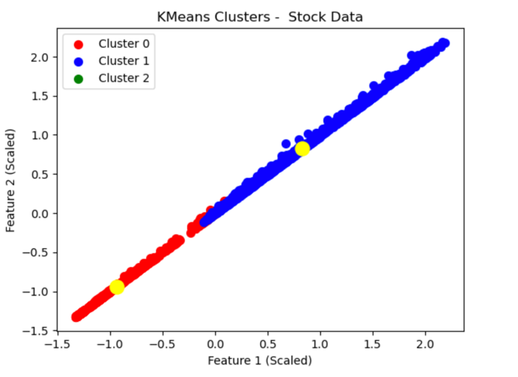
- The result shows the stock data was divided into two clusters, where Cluster 0 represents lower price values and Cluster 1 represents higher price values, indicating different trading patterns.

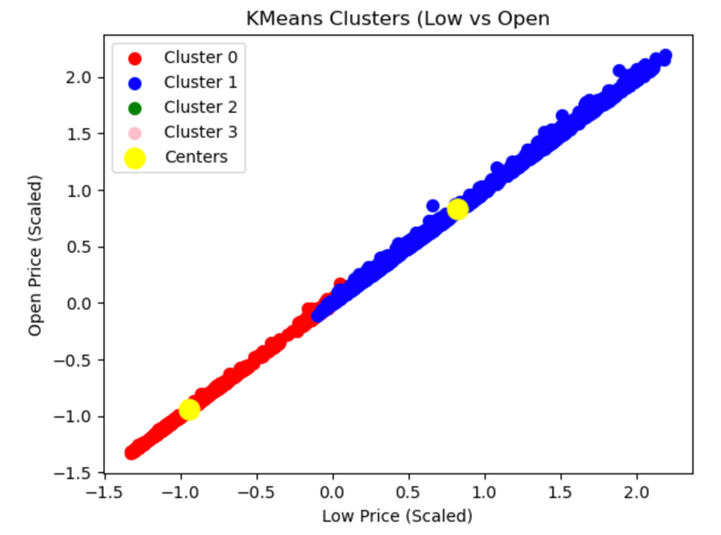
This picture show a two groups of Low and the Open prices feature while additional clusters had little or no clear separation.

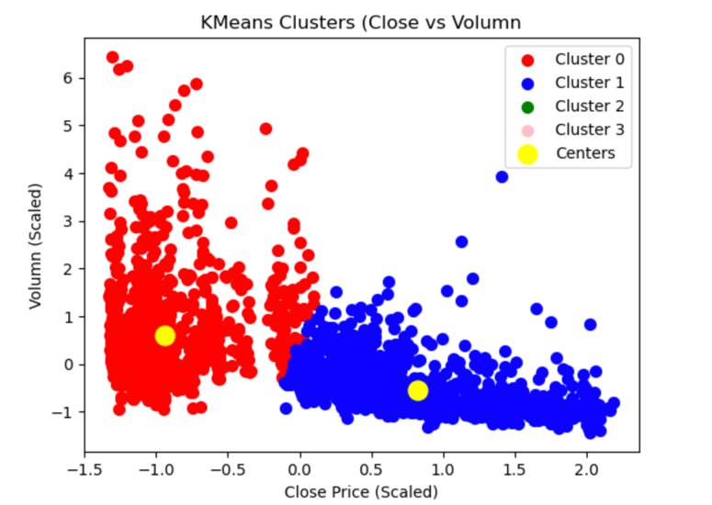
- Clustring for lower Closing price represented and (0) Volume has a high trading compared to cluster (1) higher closing price with lower trading volume which indicate different in market behaviour

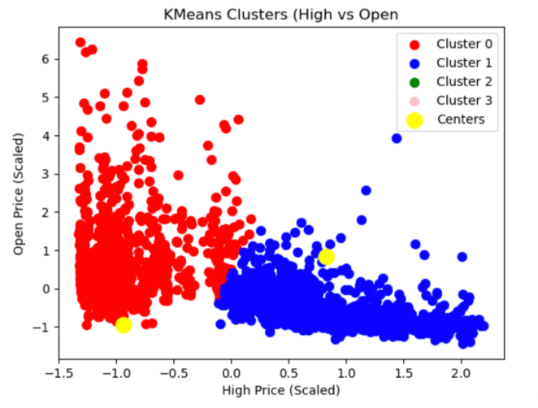

Cluster (0) represents lower price periods and Cluster (1) represents higher price periods, which shows changes in Apple trading levels from time to time.

Elbow Method
The Elbow method serves to support the K_Means test determine the accuracy of the clusters formed because not all clusters are according to the needs of analysis (Wang et al., 2021).

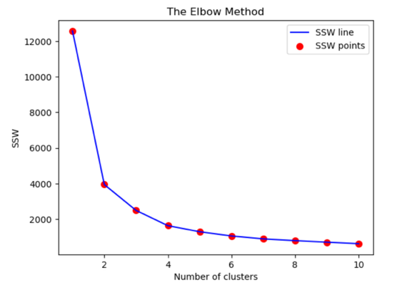

The Elbow method shows in this picture the SSW drops from 1 to 3 clusters then it becomes slower in improving. This shows that 3 clusters is ideal number of clusters, and if more cluster is added it might give small reduction on SSW which results in limited benefits.
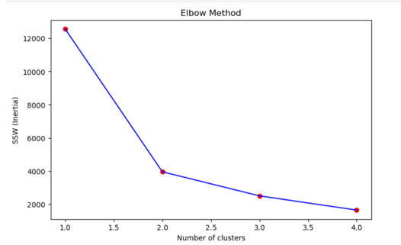

Here is a decrease in SSW from 1 to 2 clusters. This shows that only 2 clusters is the optima number of clusters.

Silhouette Score
By assessing both inter-cluster separation and intra-cluster cohesion, silhouette assists in determining if a data object was correctly assigned to one cluster rather than another. (Bruno et al., 2014). The results shows that two clusters has a high score of 0.60 which provide the best separation and best group for the stock data and the more clusters is added, the performance decreases. A comparison between K-Means and Agglomerative clustering using Davies-Bouldin Index and Silhouette Score has been done. With a lower Davies-Bouldin Index (0.5696 vs. 0.5745) and a higher Silhouette Score (0.6038 vs. 0.5382), it shown that the K_Means worked better for the stock data, suggesting stronger cluster separation and more compact clusters.

Arima / Serima Time series
Time Series measure any type of information or data points that happened in a specific time intervals which it was useful to apply In this project.

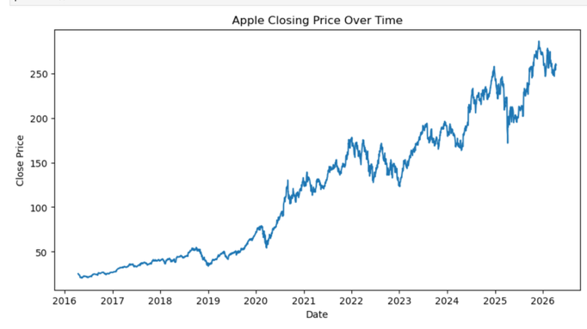

- This graph show a high increase in Apple closing price from 2016 to 2026
- Fluctuations and some drops in price indicates market volatility.
- Suitable for Arima/Sarima model

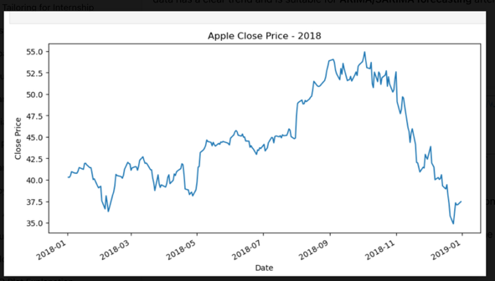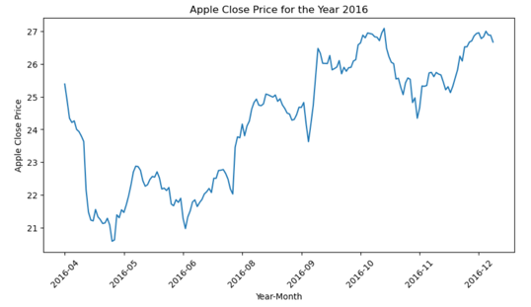

- 2016 Close Price: Although Apple's opening price fluctuated somewhat, it ended the year higher, suggesting a steady rising trend.
- 2018 Close Price: Apple's closing price saw significant fluctuation as it rose over the first three quarters, peaked at about $55, and then plummeted precipitously toward the end of the year.

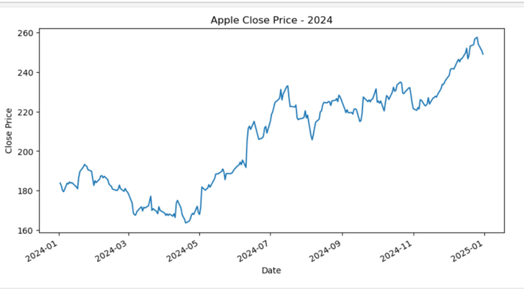

- 2024 Close Price: a strong upward trend with some fluctuation in the beginning of the year indicates market improvement and growth.

Seasonality
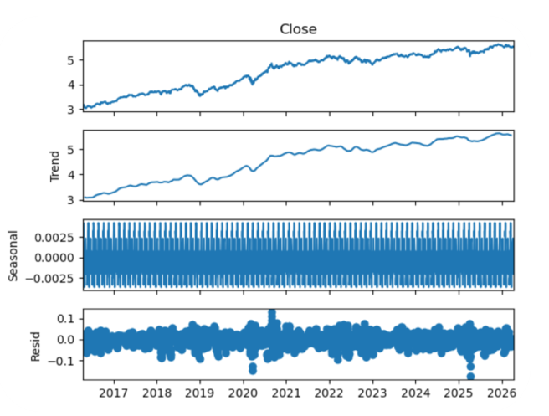
Graphs shows the closing price for Apple has an upward trend from 2017 to 2026. The seasonal component is presented smaller than the trend component while residual has random fluctuations that shows a short term market shock. Overall it shows a mild seasonality.
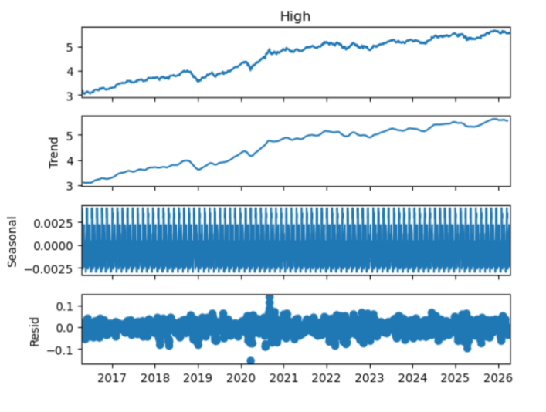
As the trend shows an upward increase ,seasonality in the high pricing feature is small and consistent whereas the residual. Components has a some spikes fluctuations. it shows a short term volatility.
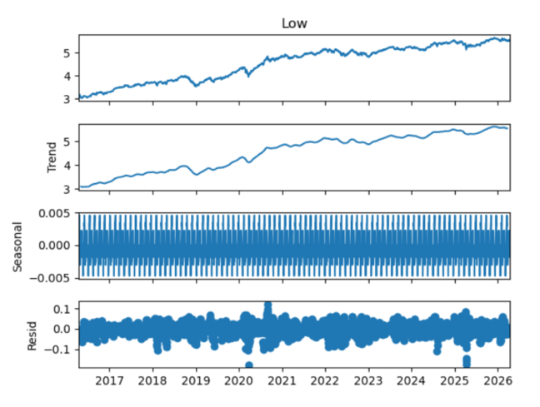
The residuals exhibit random oscillations and a few spikes, indicating short-term market volatility, but the seasonal component is minimal and consistent.

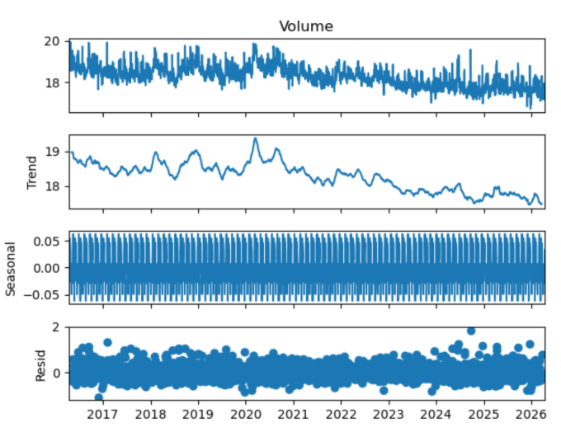

There is a minor decrease trend over time in the decomposition plot for Apple's volume. The residuals show many spikes that indicate erratic trading activity and abrupt market events, while the seasonal component is greater and more noticeable than the price factors.

Arima
ARIMA model have demonstrated effective short-term forecasting capabilities. In short-term prediction, it consistently performed better than intricate structural models (Genre et al., 2013). Appropriate ARIMA parameters were estimated using ACF and PACF graphs.

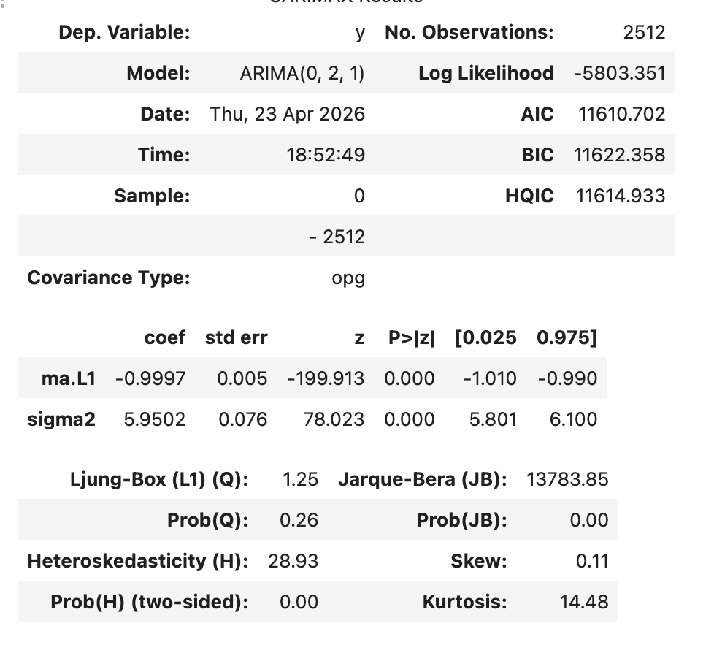
The AIC was used to compare the Model performance, it showed that lower values of 11608.10have a better trade-off between model fit and complexity. This is a balanced result in the financial area as stock prices usually behave just like a random walk process which is a goal to achieve stationary.
- Close Price: ARIMA an acceptable result of (0,1,0), r2 0.99- high number between predicted and observed values with the forecasted price was expected to lie between 254.51 and 264.08.provide a good estimate in particularly in volatile financial markets.
- Low price: ARIMA(2,1,1), minimum AIC value of 11246.76, his is expected because daily low prices are more sensitive to short-term market volatility and intraday fluctuations.
- Open price : ARIMA(2,1,2) producing the lowest value of 11787.47, R² score of 0.9989, forecast at approximately 259.96, with a 95% confidence interval between 254.98 and 264.94.
- Volume: ARIMA(1,1,2), with a minimum AIC value of 94412.54.results indicates volume trading is difficult to forecast using univariate ARIMA methods due to it dependence on unpredicted market events.

Serima Model
An adaptation of the ARIMA (Autoregressive Integrated Moving Average) model, SARIMA (Seasonal Autoregressive Integrated Moving Average) was created especially to deal with time series data that show seasonal patterns (Milvus.io, 2025).
- Close: The Serima model produced an AIC of 11627.46 which is higher than the Arima model. This suggest that the Arima model was better in value. This suggests that Apple stock prices did not exhibit strong regular seasonality over the study period.
- Open: Sarima model results an AIC of 11810.288 indicates a stable diagnostics
- Volume : Serima AIC 94550.347. Arima model showed a better performance indicating that volume did not exhibit reliable seasonal behaviour and remained difficult to forecast accurately.

Conclusion
This Project applied clustering between two points, time series plotting data in a specific time interval to the Apple stock data between 2026-2026. Overall, Arima model have performed a better value than the Serima Model with result of a lower value of AIC. Results have shown that the machine learning and clustering generate useful insight into the problem domain of this project.

References
- ‘Big Data Analysis as a Source of Companies’ Competitive Advantage: A Review’ (2018) Entrepreneurial Business and Economics Review, 6(4), pp. 197–215. Available at: https://www.ceeol.com/search/article-detail?id=789008.
- Wang, B., Wang, G., Wang, Y., Lou, Z., Hu, S. and Ye, Y. (2021). A K-means clustering method with feature learning for unbalanced vehicle fault diagnosis. Smart and Resilient Transportation, 3(2), pp.162–176. doi:https://doi.org/10.1108/srt-01-2021-0003.
- Bruno, G., Cerquitelli, T., Chiusano, S. and Xiao, X. (2014). A clustering-based approach to analyse examinations for diabetic patients. In Healthcare Informatics (ICHI). IEEe, p.(pp. 45-50).
- Genre, V., Kenny, G., Meyler, A. and Timmermann, A. (2013). Combining expert forecasts: Can anything beat the simple average? International Journal of Forecasting, 29(1), pp.108–121. doi:https://doi.org/10.1016/j.ijforecast.2012.06.004.
- Milvus.io. (2025). What is SARIMA, and how is it different from ARIMA? [online] Available at: https://milvus.io/ai-quick-reference/what-is-sarima-and-how-is-it-different-from-arima.

‌

